Massimo Aliberti, Imperila College London, 2017. https://drive.google.com/file/d/1pa8EQhqbvVkq0DwAQcdvMnTzyhnwMM4x/view?pli=1

- Compliance risk:
  - People’s answers will be influenced by their own personal impression of what they are expected to answer.
  - Politeness
  - Desire of Approval
  - Avoid declaring what you decided to do with your project. It influences the respondent, especially in face to face interviews.
    - For example: tell me the last time you did x thing. In this case “search for a touristic destination.
  - Avoid adding information in the question, about what other people do.
  - Compliance risk mitigation:
    - “Mom test” (Rob Fitzpatrick). Ask questions that even your mom could answer honestly.
    - Short open questions, without framing and introduction.
- Offset risk:
  - Forcing people about problems they are not aware of.
    - Your main objective is to determine what your customer’s problems are, in their own perspectives and wareness, not yours.
  - Forcing people to consider a specific problem as more complex than they normally would.
  - Suggesting them a description of a specific problem with different words than they would normally use.
  - Introducing terms that people don’t know/use reduces your opportunity to understand how to effectively describe and position your product so that people would easily find it.
    - Do you use “social commerce”? I’m including specific terms that I may know but not the respondent.
  - Keep your personal view of the problem, its complexity and description, out of the interview.
    - Never describe the problem.
- Speculation Risk: Asking people to predict their own behavior in an hypothetical, future situation.
  - People are not generally good at determining what they would do in an hypothetical scenario that never happened to them.
  - Speculation risk mitigation:
    - Talk about past and present user’s experience.
    - Ask them to tell “stories” about what they normally do and don’t do, then try to understand why they act that way.
    - Keep in mind that they are not able to correctly determine the underlying reasons for their own behavior. You’ll have to0020investigate progressively and with patience.
    - Exmaples:
      - Tell me about the last time you booked a vacation: where did you start?
      - Why didn’t you use…?
      - If it’s due to price, how did you check?
- Defining your target: you have to define who has to be consulted according to your objective.
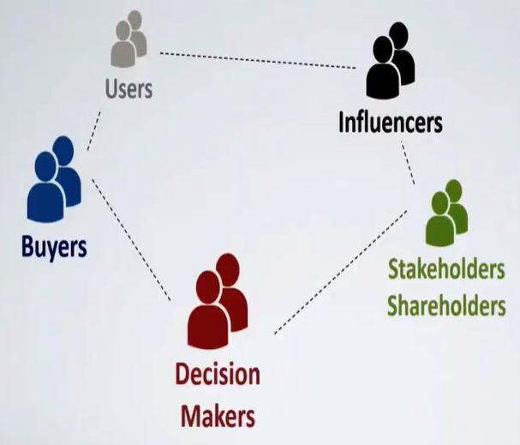
- Access path:
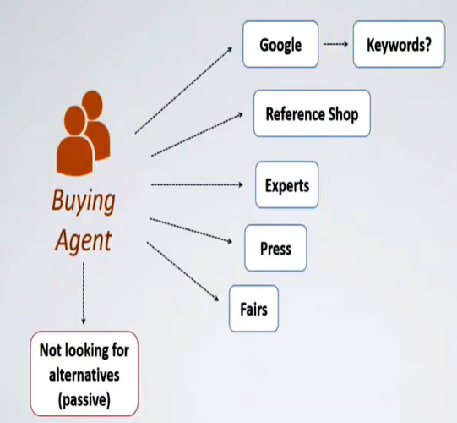
- Alternative:
  - What do they like about their current process?
  - Did they eve consider an alternative in the past? Better or worst? Why it changed?

